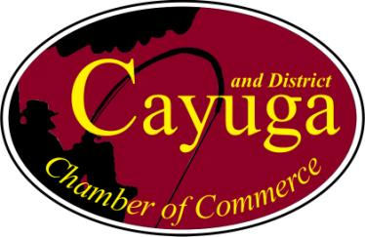
2024-2025
Membership Application

Please complete this form and return it to the Cayuga Chamber of Commerce .
Company Name/Organization/Individual:
Address:
Phone: Website:
Email address:
Representatives:
Description of Business:
Check One | Membership Type | Fee | HST | Total | Paid
 | Business | $125.00 | $16.25 | $141.25
 | Private/Individual | $25.00 | $3.25 | $28.25
 | Non-Profit Organization | $25.00 | $3.25 | $28.25

Please circle YES or No for the following:
Please send my business information on the Chamber’s Group Health and Life Insurance: YES or NO
I/or a member of my business would be interested in serving on the board: YES or NO
Payments can be made via EMT to cayugachamberofcommerce@gmail.com please use the password “Cayuga” or by cheque payable to Cayuga & District Chamber of Commerce.

